OneChair Clip Information Guide

By AfterFlow Mods

Hello. If you are reading this, it might be because your are interested in suiting up your OneWheel with a chair. **Good news!** We have a solution just for that. But there are some barriers that have to be crossed in order to completely this task safely and effectively. To begin, let’s go over some comments:

1. **Please wear a helmet!** It is not any safer to be sitting than standing on this device. Please use common sense. We are not liable for any sort of injury or harm done to the rider or Onewheel if improperly used.
2. **If you are printing the clips on your own, the keep in mind the clips are only as strong as the plastic!** We have added our best result settings when printing with different materials in the *Printing Instructions and Comments* section on page (). Please keep in mind that experimenting with settings and such can lead to cracking/breaking at various stress points.
3. **Follow the build guide** for the best performance out of the clips. As much as we do love print-and-go products, this does require some additional work. You can find the instructions and additional parts required along with recommendations in the *Building and Testing* section on page ().
4. **We’re learning too.** We’re college students at the time of creating this product. We don’t know everything that is out there when it comes to creating mods. Comments, questions, or concerns? Let us know what you think! Information can be found in the *Contact Us* section on page ().
5. **Have fun!** We know this is very “summer camp leader” sounding, but nothing beats making a part/product/concept/prototype people can play and laugh with while using. We love the reactions from riders and passerbyers alike. Think you have some content? Tag the photo or video with #Onechair or follow us on Instagram @after.flow.

**What is this all about?**

To begin, this product came to be from humor. At first, we had a lawn chair simply wrapped with saran wrap on the bottom bars. This created enough friction to hold the chair in place while sitting on it. At first, we really didn’t imagine it would work that well (or at all), but to our surprise, the system was not only able to be controlled both forwards and backwards, but in any desirable direction compared to standup riding. So we went with it, then we started to experience undesirable results (as you may imagine) with proper adhesion to the Onewheel. So, with that, the Onechair Clips were created.

**How to Ride the Onechair**

**Building and Testing**

**Note: These clips are a work in progress/prototype, so there may be changes/additions that will be updated on this part of the document as we go along.

**Tool List**:

* 3D printer (Minimum 4 x 4 x 5 inch build area)
  + We used a combination of an Ender 3D Pro (highly recommended if looking for a cheap, good printer) and a Ultimaker 2.
* hairdryer or heatgun
* Beach Chair
  + Beach chairs seem to work the best as the clip hold design is the best fit. We found this chair to be the best:
    - <https://www.walmart.com/ip/Caribbean-Joe-Folding-Beach-Chair-Blue-Stripes/799432363>

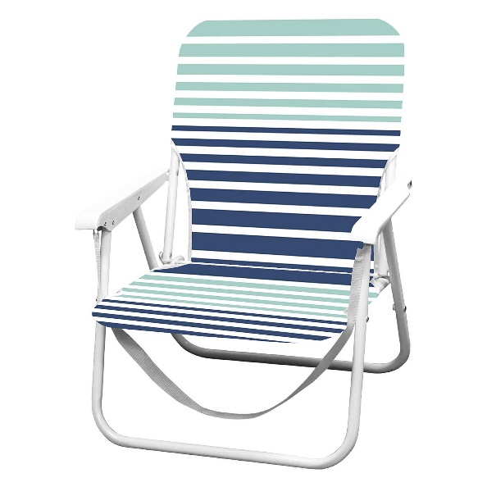

**Parts List**:

* Felt Blanket Sticky Pads
  + This is used to create friction between the clips and grip tape, while as protecting yourself and the board. We used these felt pads from Home Depot, as we cut them to size. Anything used for furniture wood floor protection should work.
    - <https://www.homedepot.com/p/Everbilt-2-in-x-4-in-Heavy-Duty-Self-Adhesive-Beige-Felt-Blanket-3-Pack-804614/306229475>
    - 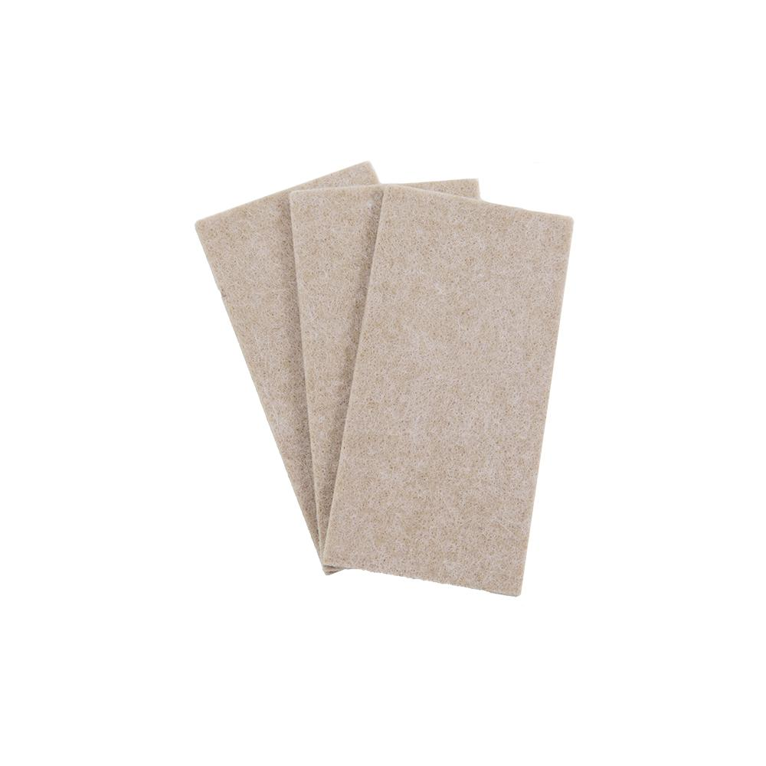

**Printing Instruction and Comments**

As mentioned before, the clips are not perfect. But here are the settings we used with our printer:

Keep in mind that cracks and abrasion can form from use on these clips. Use at your own risk if you recognize anything of the sort!

**Contact Us**

Have a question, comment, or concern? Let us know at: